FactoryPulse changes since yesterday evening
  - Illustrated review from 2 November evening to 3 November 2026
Prepared for Narendra and the Phase 1 project review. This report explains what changed, where it appears, and what was actually verified. The main result is stronger role access, shift and maintenance tools, a saved MySQL Power BI report, a working ticket resolution flow, and source-derived notebook evidence.

Scope and evidence
“Yesterday evening” is interpreted as 2 November from about 6 pm, Asia Kolkata time, through the work completed on 3 November. The activity handoff, changed source files and saved verification results establish this scope. Existing morning and afternoon features are not presented as new overnight work. Screenshots captured on 3 November show the interface at capture time; live values naturally change.
Change group | Where to find it | Report section
Role and team restrictions | Authorized role pages and APIs | 2
Shift tracking and previous shifts | My Production and role dashboards | 3
Service plans and observed usage | Maintenance and Manager panels | 4
Costs and contribution calculator | Manager panel and Admin settings | 5
Resolve assigned tickets | Maintenance and incident pages | 6
Saved Power BI report | Power BI Desktop | 7
Pinned chat and Gemini | Middle left assistant icon | 8
Executed notebook and corrected statistics | Jupyter notebook and evidence files | 9
Documentation and contributions | Project reports and contribution file | 10
Retention alerts and onboarding | Admin controls and backend workers | 11

Passwords, API keys and database connection secrets are excluded. We preserved existing accounts and the separate Simulator pipeline. This is a change report, not a claim that every possible feature has been certified.

2 Role access and responsibilities
Supervisor access was tightened from general fleet access to the configured machines and operators in that supervisor’s team. The backend applies this scope to machine records, telemetry, downtime, incidents, work orders and machine questions. A supervisor with no allocation fails closed. Operators remain restricted to their assigned station.
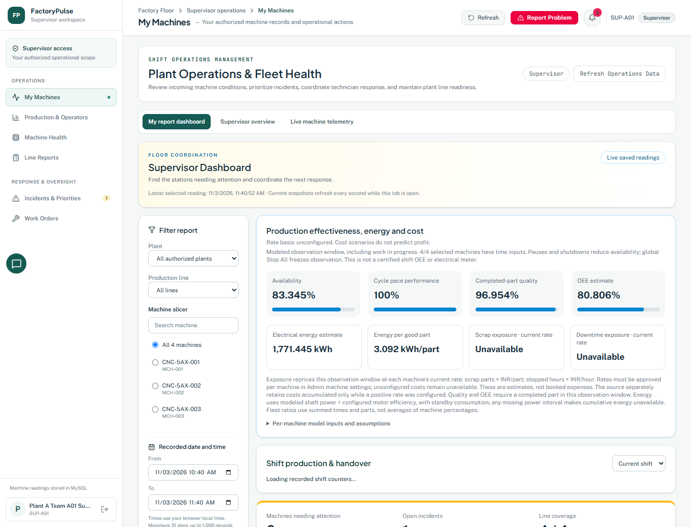
Figure 1 Current Supervisor workspace and role navigation. Screen capture of the live application.
- Verified team samples included four-machine and two-machine supervisor groups. Other operational roles retain their authorized wider scope.
- The previous workforce creation is background: accounts were already created before this evening window. No new passwords or team-member credentials were created for this report.
- Role restrictions are checked on the server. A screenshot shows the permitted experience but does not, by itself, prove access control.
Evidence: api_server/team_access.py; docs/OPERATIONAL-READINESS.md; .local/extended-readiness-live.json. The live check recorded Operator scope of one machine, Supervisor scope of four or two, and Maintenance and Manager scope of 40.

3 Current shift production and handover
A dedicated shift panel now uses 12-hour local shifts, beginning at 6 am and 6 pm, with a target of 120 parts per machine. Production is calculated from counter changes over the observed shift, handling counter resets rather than adding cumulative samples.
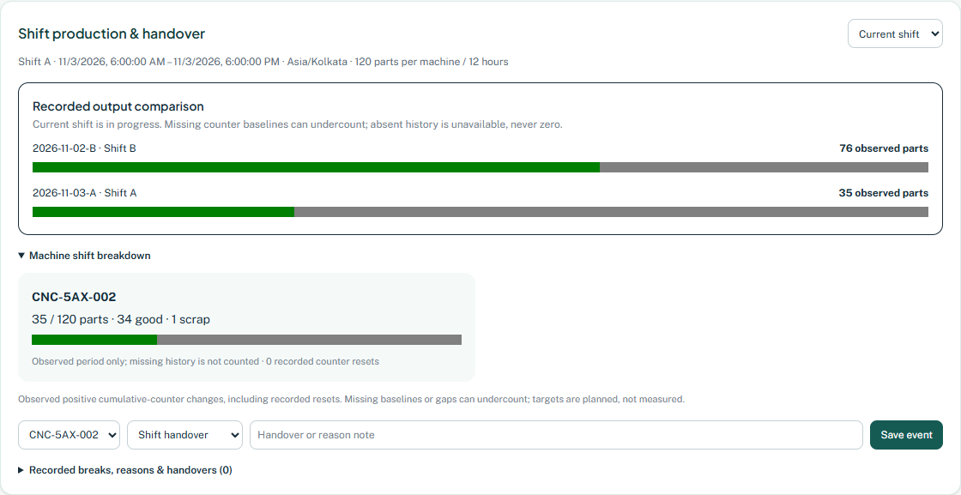
Figure 2 Current Operator shift panel, including observed output, target and handover or break controls.
- Current shift events: handover, break start, break end and downtime reason. Events are saved with the user and time.
- Break transitions are validated; absent history is shown as unavailable rather than invented zero production.
- Shift start and end audit events are bounded to avoid repeated records. The Operator can write only for the assigned machine.
The session timer is not payroll attendance or productive working time. Captured counts are observed model counters, not certified physical production totals.

3 Previous shift comparisons
The Recorded shift selector adds historical shift views and a previous-shift output comparison. The UI offers the current shift plus the previous 26 shifts; the backend supports offsets through 27 so it can retrieve the comparison shift.
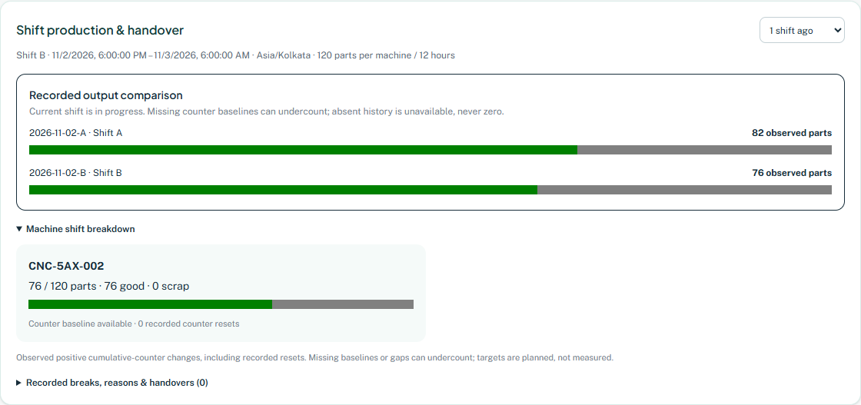
Figure 3 Previous shift selected. Event-writing controls are hidden for historical shifts.
Manager views are read-only and collapse the per-machine breakdown to avoid crowding. An observed counter baseline is distinguished from a fully covered shift. This keeps partial data from being presented as a complete shift total.
Limit: sensor history retrieval is bounded. A complete 12-hour shift at one-second sampling can exceed the current per-sensor history cap and needs a durable shift rollup. We have not claimed full historical reconstruction for every shift.
Evidence: src/components/ShiftOperations.tsx; api_server/shift_tracking.py; docs/SHIFT-SERVICE-COST-EXTENSIONS.md.

4 Maintenance plans inspections and observed usage
Maintenance gained service plans, an inspection checklist and inspection history. A later extension added service triggers based on observed running hours and completed parts. The worker saves checkpoints so a page refresh does not restart the service baseline.
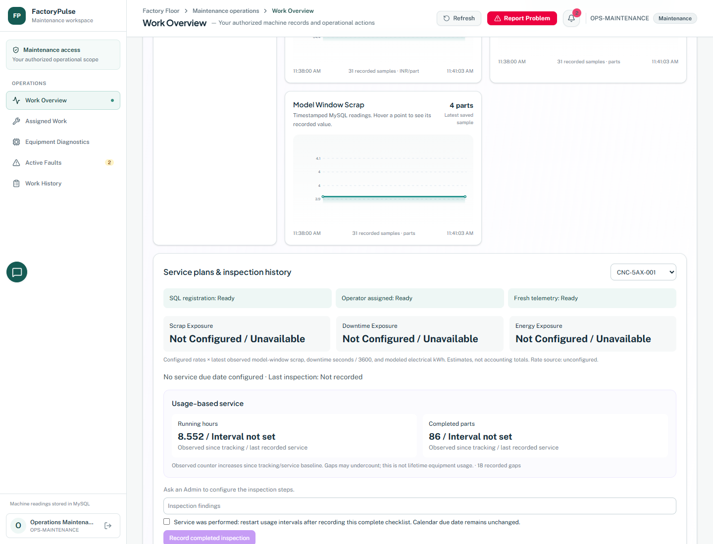
Figure 4 Maintenance service panel with SQL registration, operator allocation, telemetry readiness and observed usage.
- Admins can configure a calendar due date, up to eight inspection steps, and optional service intervals in hours or completed parts.
- Maintenance records the checklist and findings. Explicit service completion restarts only the observed usage interval; it does not silently move the calendar due date.
- Tracking starts from new observed baselines. It ignores duplicate or out-of-order readings, handles counter resets and flags gaps over 60 seconds.
An interval that is not configured remains “Interval not set.” Running hours are observed since tracking or recorded service, not lifetime equipment hours. Real SQL checks used rollback transactions, so they did not create a false completed physical service.

5 Costs and contribution planning
The calculator now explains scrap loss, lost contribution from downtime and the selling price needed for a target contribution margin. It separates factory-approved inputs, internship estimates and unconfigured rates.
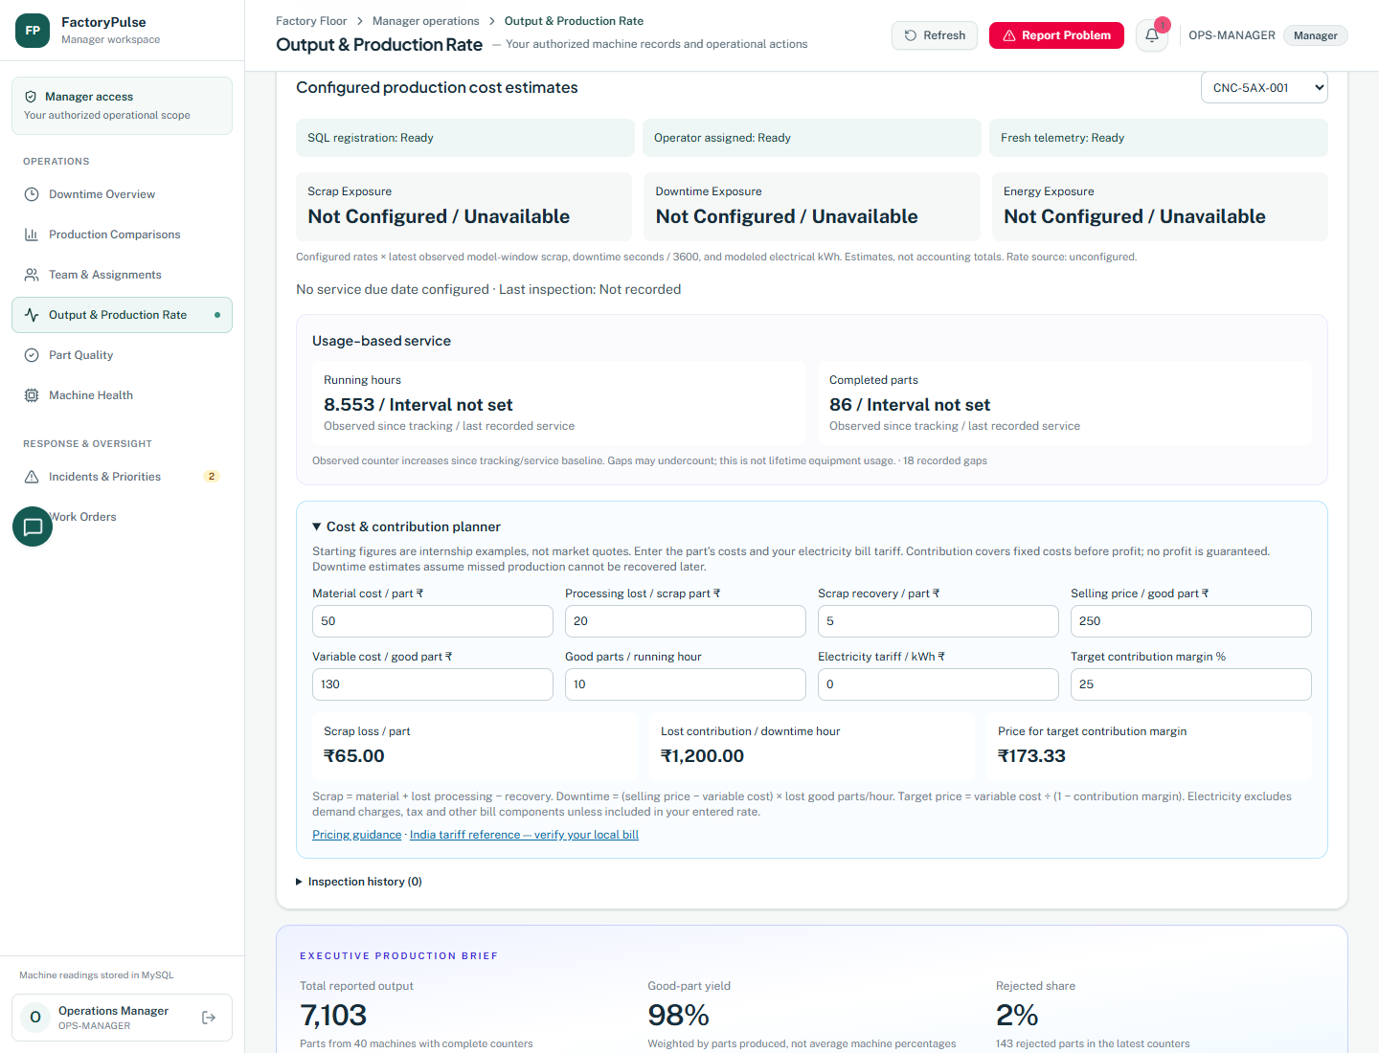
Figure 5 Expanded Manager planner. Current cost exposure cards correctly remain unavailable when machine rates are not configured.
- Example scrap loss: 50 material + 20 processing − 5 recovery = 65 rupees per scrap part.
- Example downtime: (250 selling price − 130 variable cost) × 10 missed good parts per hour = 1,200 rupees per hour.
- At 25 percent contribution margin, 130 ÷ 0.75 = 173.33 rupees. Margin and markup are not treated as the same calculation.
- Admin can copy estimates into settings for review. Manager scenario inputs do not silently change approved settings.
These are transparent internship scenarios, not verified market rates or a profit guarantee. The electricity tariff remains unset until a valid local bill rate is supplied. Energy and cost outputs are estimates where the source values are modeled.

6 Technician ticket resolution
Maintenance now has a direct Close ticket and Resolve incident action for its assigned incidents on the work overview, work-order and report pages. The dialog requires meaningful repair and verification notes and confirmation; duplicate submissions are prevented.
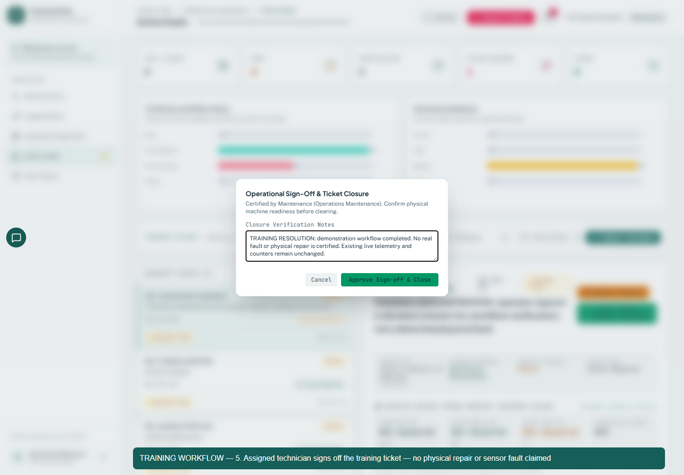
Figure 6 Actual sign-off form used in the recorded training workflow. Notes explicitly state that no physical repair is certified.
The MySQL transaction closes the incident, records who closed it and when, completes linked work orders and writes audit events. The UI displays Closed as Resolved. Current-session refresh is immediate; other sessions receive their normal polling update.
Authorization checks rejected Operator, Manager, Admin and a different technician for the close operation. Whitespace-only notes are rejected. Closing an incident twice returns a conflict. Completing only a work order remains separate from resolving the incident.

6 Recorded workflow and shared resolution
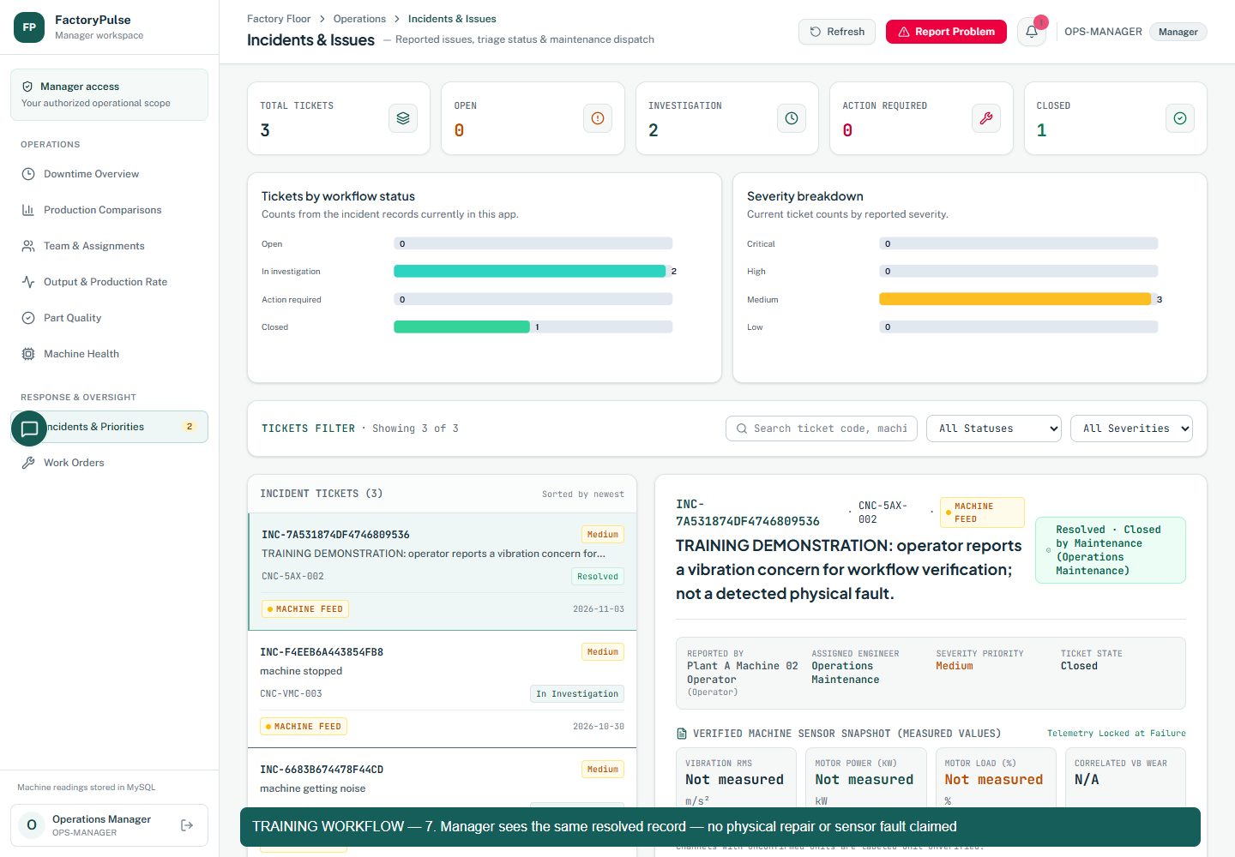
Figure 7 Manager sees the same resolved incident after the assigned technician closes it.
Step | Actor | Stored state
Fault concern reported | Operator OP A002 | Open
Technician assigned | Supervisor SUP A01 | In Investigation
Investigation and repair notes saved | Assigned Maintenance | Action Required
Sign off recorded | Assigned Maintenance | Closed displayed Resolved

Ticket INC-7A531874DF4746809536, incident ID 7, machine CNC-5AX-002. MySQL confirmed the linked work order as Completed and all four incident audit events. Operator, Supervisor, Maintenance and Manager fetched the same Closed record. The saved local Admin credentials did not authenticate, so that login check is not claimed.
The video uses real browser forms and live APIs without mocked responses. It is a manually reported training fault; no sensor fault was injected and no physical repair was performed. Existing machine streams and production counters were not reset. Video: reports/phase1/FactoryPulse-workflow.webm.

7 Native Power BI report
A new FactoryPulse Machine Overview PBIX report was saved and manually refreshed using native MySQL Import. The verified check loaded 1,280 latest sensor rows and a 40-machine snapshot. This is an actual Power BI Desktop file, separate from the app’s own charts.
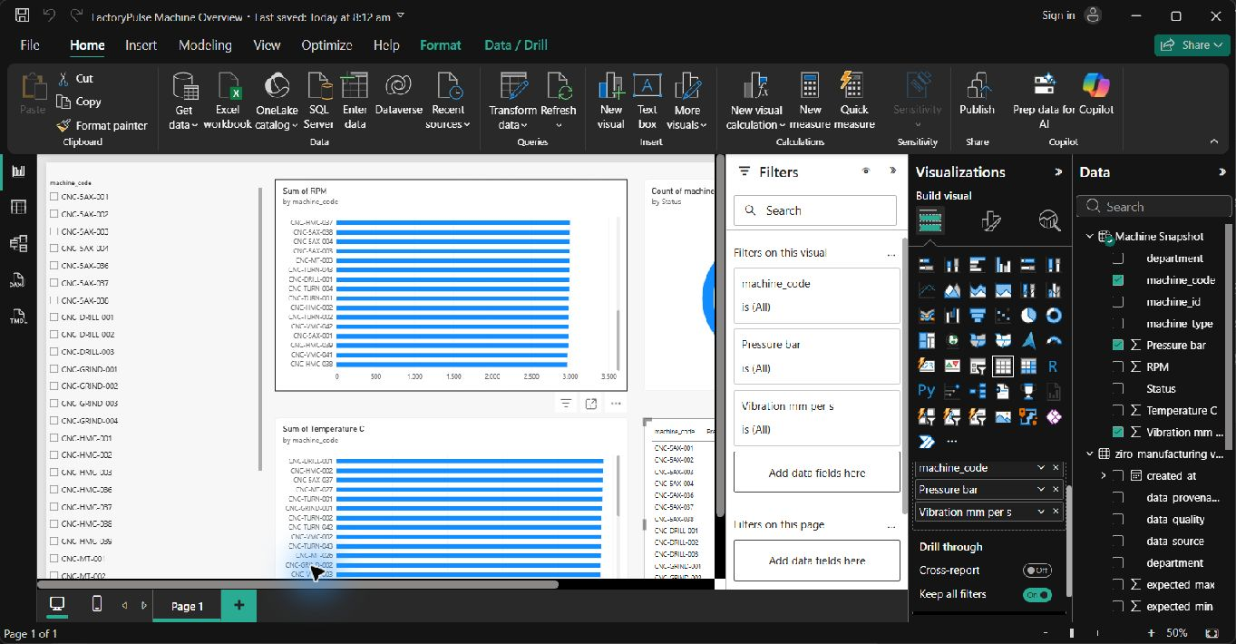
Figure 8 Saved report open in Power BI Desktop editing view. The Filters and Visualizations panes cover part of the report canvas.
- Visuals: machine slicer, RPM and temperature bar charts, machine-state donut, and pressure and vibration table.
- The snapshot keeps one row per machine. Numeric GOOD readings are used; pressure and vibration are not summed across samples.
- The slicer was checked from 40 machines to one and back. Original external reports using synthetic or sales data were preserved.
Refresh is manual Home then Refresh in Import mode. Cloud publishing, a gateway, scheduled refresh, Power BI row security and embedding into the app were not verified. The app’s live polling is a different mechanism. File: powerbi/FactoryPulse Machine Overview.pbix.

8 Pinned assistant and optional Gemini
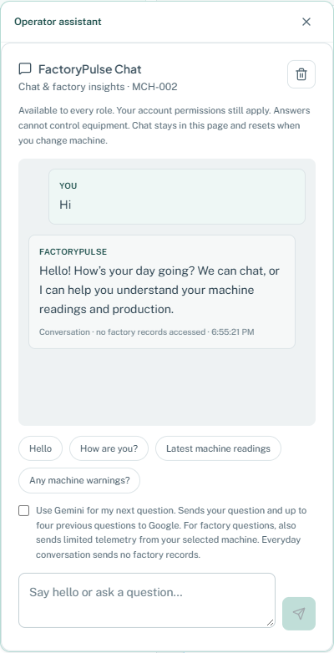
Figure 9 Assistant placement captured on 2 November at about 6 55 pm. It shows the new middle left pinned icon and panel.
- The assistant moved to a small middle-left icon with a responsive panel, Close and Escape handling.
- Greetings and basic help can stay local. Everyday AI conversation does not read factory SQL records.
- Factory questions keep selected-machine authorization. Gemini is optional for each question; consent resets afterward. Credentials and personnel requests are handled locally.
Today’s provider verification returned an actual MCH-001 temperature answer of 47.71 degrees C, matching the supplied source reading and expected range. It separated observations from tentative recommendations. The configured model failed; one bounded fallback to verified gemini-3.5-flash responded. Local key and model settings were preserved. Provider availability can vary; SQL evidence stays usable on failure.

9 Notebook calculations from actual sources
The notebook was rebuilt from five unexecuted cells and manually entered summaries into nine executed code cells with saved tables, calculations and plots. It reads 22 original CSV files and records file hashes so the inputs can be identified.
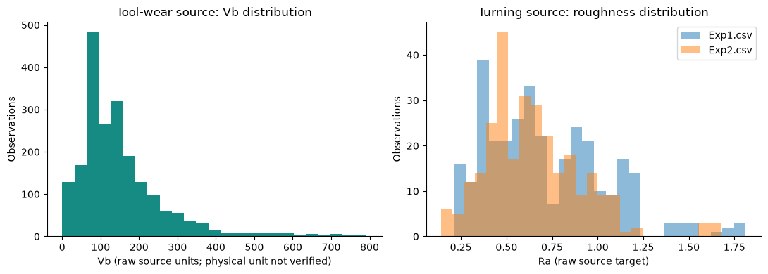
Figure 10 Actual saved notebook output showing source distributions. This is Jupyter analysis output, not a main-app dashboard.
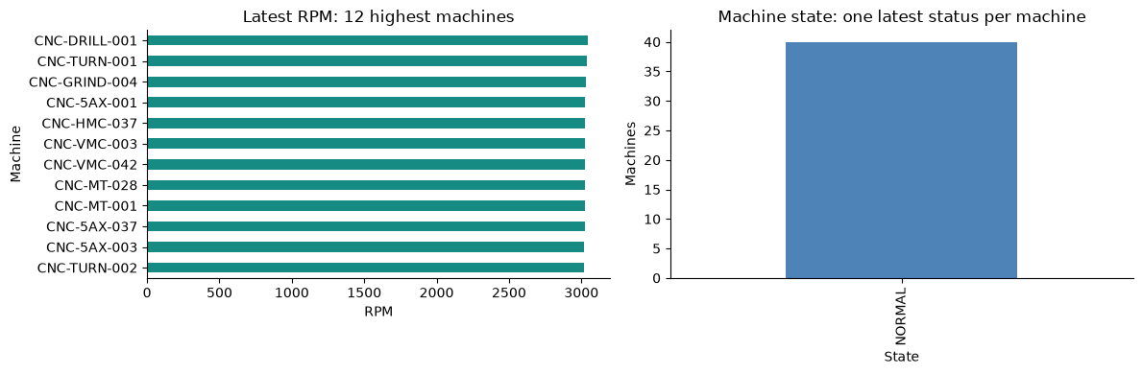
Figure 11 Actual saved notebook output from the MySQL latest-reading view. This is a fleet snapshot, not historical OEE.
The calculations include count, mean, median, sample standard deviation, quartiles, 95th percentile, minima and maxima. Independent standard-library calculations reconcile with pandas. Statistics keep different sensor units separate and exclude invalid or non-GOOD readings from arithmetic without deleting source rows.
Notebook: notebooks/eda_manufacturing_datasets.ipynb. Saved outputs and exact snapshot: reports/phase1. No database writes were made by notebook execution.

9 Data corrections and validation changes
Source group | Rows | Original columns | Missing cells | Duplicate value rows
Tool wear | 2,054 | 154 | 1,142 | 0
Turning roughness | 612 | 27 | 900 | 0
Mill telemetry | 25,286 | 48 | 0 | 331
Milling life | 968 | 131 | 0 | 0

- Turning Exp1 has 324 rows and Exp2 has 288; the old 306 plus 306 statement was incorrect.
- Mill telemetry has 48 original columns. Source filename is an added provenance column, not an original sensor.
- The milling source has an extra header row and decimal commas; parsing now handles both, including all 968 normalized target values.
- The tool-wear Vb mean is about 151.104 in raw source units. Its physical unit is not verified, so the earlier millimetres claim was removed.
- CycleToFailureNormalized is target leakage for predicting CycleToFailure and is excluded from predictors. No trained ML model is claimed.
- The canned validator was replaced with file reads and computed results. The historical filename still contains import, but it does not load data into MySQL.
- Constant self-comparison tests were replaced with real fixture calculations: missing sources, invalid values, sample deviation, duplicates, decimal commas and separate units.
Important finding: all four MySQL research tables exist but contain zero rows. The notebook research analysis uses the local original CSV files, while operational readings are read from MySQL. CSV-to-MySQL research ingestion is still a separate gap.
This page describes data work, which has no new app button. Figures 10 and 11 are the genuine visible outputs; no invented app screenshot is used.

10 Documentation and named contributions
The main release document, Power BI README and test reports were rewritten to reflect the current interface, ports and measured results. Old versions were retained under docs/archive so the history was not erased.
Document or evidence | Change
PHASE1_V1_DOCUMENTATION.md | Current light interface, local ports, real data path and explicit limits
docs/PHASE1-VERIFICATION.md | Authoritative evidence index and reproduction steps
powerbi/README.md | Actual MySQL Import report and manual refresh limits
tests/TEST_EXECUTION_REPORT.md and JSON | 18 current targeted tests instead of unsupported broad release claims
CONTRIBUTION_EVIDENCE.md | Named Narendra Git evidence with commit IDs and AI assistance limits
Operational readiness and shift notes | Marked as implementation history with link to current evidence

Contribution evidence now cites Vadde Narendra’s actual repository identity and commits, including 38cd961, 6649dc1 and ae77c6d. Git attribution establishes the repository author, not sole personal authorship. The report does not assign anonymous engineering roles to invented people.
Other team members must still provide their full names, work personally completed, dated files or commits and reviewer confirmation. The executed notebook and recorded workflow are project evidence; they are not automatically individual contribution proof.
Documentation changes have no new app screen. They are visible in these project documents. The screenshots in this report cover their corresponding interface features; backend-only work is separately identified below.
Current checks: 18 targeted tests passed, nine notebook cells executed without errors, and the recorded workflow browser had zero page errors. This is not a guarantee of every possible application action.

11 Backend safeguards and Admin controls
The following overnight changes support the interface but are not new charts. Admin-only panels require an actual Admin session. Because the saved local Admin credentials did not authenticate during verification, this report does not invent a fresh Admin screenshot or reset that account.
Change | Behavior and evidence | Limit
Storage retention | Two MySQL tables support hourly summaries and duplicate-reading protection. Raw retention uses bounded batches; latest, pending or failed delivery and audit data are protected. | 14 day raw policy; bounded 500 rows per minute. Not a hard disk limit or automatic SQLite vacuum.
Sustained sensor alerts | Fresh GOOD physical readings outside configured bounds must persist at least three distinct samples and the configured duration. One open machine and sensor incident is allowed. | Policy checked; no induced live automatic-fault lifecycle recorded.
Machine onboarding | Admin validates SQL machine, plant, team capacity and existing allocations, then registers a stopped sender profile using backend-only authorization. | Temporary database onboarding tested; no extra live QA machine added.
SQL registry | Approved 40-machine metadata registered; nullable inspection and required metadata columns added with schema-owner access. | No fabricated installation or inspection dates; no database privileges widened.
Usage worker | 15 second observed usage checkpoints, first-sample baseline, reset handling and gap flags. | Not lifetime hours; missing intervals can undercount.
Notification boundary | MySQL remains authoritative. Supabase does not proxy notebook, app or Power BI queries. | Cloud delivery remains disabled.
Service continuity | Main API restarted when needed; separate Simulator left running for this evidence work. | Six second check saw 37 machines advance and 1,184 streams change; not a one second latency guarantee.

Existing features that were preserved rather than newly created overnight include the 40-machine roster, earlier multi-machine sender controls, emergency Stop All, older chart redesigns and previously provisioned workforce accounts. No new GitHub push is claimed.

12 Files and next actions
Project folder
C:\Users\NARENDRA\OneDrive\Documents\ChatGPT\factory pulse 2
Area | Files to inspect
Role access | api_server/team_access.py
Shifts | api_server/shift_tracking.py and src/components/ShiftOperations.tsx
Storage and alerts | api_server/storage_management.py and api_server/fault_automation.py
Onboarding and service | api_server/onboarding.py, machine_operations.py and usage_tracking.py
Costs | src/components/CostPlanner.tsx and MachineOperations.tsx
Ticket closure | MaintenanceTicketClosure.tsx, sql_incidents.py, IncidentsView.tsx and App.tsx
AI | api_server/gemini_insights.py, conversation.py and FactoryChat.tsx
Notebook and validation | scripts/phase1_evidence.py, build_phase1_notebook.py, run_phase1_notebook.py and validate_and_import_datasets.py
Evidence | reports/phase1 and reports/changes-20261103

Next practical actions
- Supply the remaining team members’ names and contribution evidence.
- If the mentor requires research data in SQL, plan and verify that import separately; current research tables are empty.
- Use approved per-machine cost rates, a local electricity tariff and equipment-maker service intervals before treating financial or maintenance estimates as factory decisions.
- Complete an induced sensor-fault test if automatic incident creation must be demonstrated.
- Use Power BI manual Refresh for the local report; cloud deployment and embedded reporting remain separate work.
- Resolve the saved Admin login credentials through the existing authorized account process; no password is exposed in this document.
Local application addresses: FactoryPulse http://127.0.0.1:3000 and AI Simulator http://127.0.0.1:5174. Backends use ports 8001 and 8002 respectively. Screenshots are dated evidence, not a promise that a local process will remain running after the computer is shut down.

